# Task 1011 Implementation

1. **Task Description: Code L6391D overcurrent protection reset mechanism in the motor controller code**

This task is to ensure that we code support for the L6391D overcurrent protection reset mechanism. The L6391D is the driver used to control the friction drive motor. There is a Shutdown pin (called SD/OD in the datasheet) that is used to reset the L6391D after it discovers an overcurrent.

For robustness, the code can also put the L6391D  in reset on a startup or when the motor is stopped.

The STMicro L6391D  datasheet is attached to this ticket in the files section. The Pin in the motor controller is PC8 -> BKOUT. Please see the schematic for the motor controller for specifics.

1. **Hardware Schematic**
2. **PMSM FOC Project Software Architecture**

(1) Timing

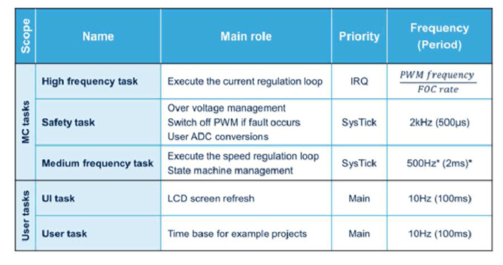

PWM: 24,000 Hz

Current loop (Torque and flux regulators): 24,000 Hz (FOC rate = 1)

Speed loop: 1000 Hz, 1ms

High frequency task: 24000 Hz

Safety task: 2000 Hz

Medium task: 1000Hz

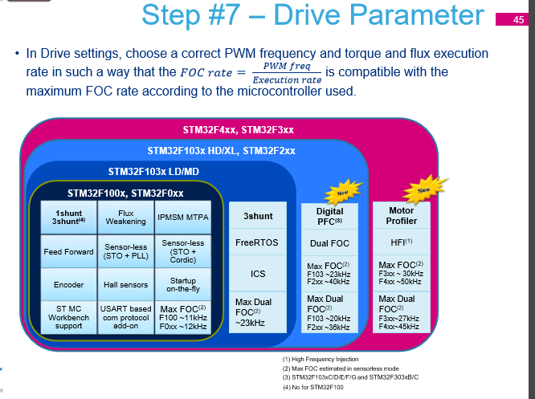

Retrieve from MC Library HandsOn p.45.

(2) ST MC Architecture: Layers

